SIMATS ENGINEERING (SAVEETHA SCHOOL OF ENGINEERING)
Department of Artificial Intelligence and Data Science
ASSESSMENT TOOL 1 – Data Interpretation

Course Code: | DSA03 | Course Title: | Natural Language Processing
CO Assessed: | CO4 – Precision | Assessment: | Assessment Tool 1 – Data Interpretation
Weightage: | 35% of CIA
CO5 Statement: | Formulate context-free grammars, feature structures, probabilistic parsing techniques and to construct parsing frameworks. (BL-4)
Student Name: | Harissh M | Reg. No.: | 192424014
Section / Batch: | AIDS | Date:

Instructions
- Read each data set, table, semantic representation, or scenario carefully before answering.
- Analyze the given information and provide logical, evidence-based interpretations.
- Show all intermediate reasoning, semantic analysis steps, predicate representations, or calculations wherever applicable.
- Answers should be concise, structured, and technically accurate.
- Support your conclusions using the data provided in the question.
- Draw diagrams, semantic networks, parse trees, or logical representations wherever relevant.
- Avoid copying definitions alone; focus on analyzing the given scenario and interpreting the data.
- Duration: 30 minutes.

Code of Conduct
I __________________________ (Name / Reg No) certify that this submission is my original work and that I have adhered to the guidelines specified for this assessment. I understand that any violation of academic integrity rules will result in disciplinary action.
Signature of the Student: _________________________

Section / Topic | Focus | Question No.
Representing Meaning & Meaning Structure of Language | Analyze semantic representations, identify action–entity relationships, detect interpretation errors, and evaluate meaning representation in chatbot systems. | Q1
First-Order Predicate Calculus & Representing Linguistically Relevant Concepts | Construct predicate representations, apply logical inference rules, derive conclusions, and evaluate reasoning in smart manufacturing environments. | Q2
Lexemes and Their Senses & Word Sense Disambiguation | Analyze contextual clues, determine correct word senses, evaluate ambiguity resolution, and improve semantic understanding in search systems. | Q3
Syntax-Driven Semantic Analysis | Analyze syntactic structures, assign semantic roles, evaluate parsing accuracy, and improve semantic interpretation in healthcare NLP applications. | Q4

Annexure A – Data Interpretation

1. Frame Semantics in Banking Customer-Service Systems
A digital banking platform uses semantic frames to understand customer requests. The NLP system identifies the action, agent, object, and destination involved in each request.
Customer Query | Generated Semantic Frame
"Transfer ₹20,000 from my savings account to my son's account." | TRANSFER(SourceAccount, Amount, DestinationAccount, Customer)
"Block my debit card immediately." | BLOCK(DebitCard, Customer)
"Send my transaction statement to my email." | SEND(TransactionStatement, Email, Customer)
"Increase my daily withdrawal limit." | MODIFY(WithdrawalLimit, Customer)
Additional transaction logs show:
Query ID | Actual User Intent | System Interpretation
B1 | Transfer money to another account | Transfer money
B2 | Block debit card | Block debit card
B3 | Receive transaction statement by email | Send statement to email
B4 | Increase withdrawal limit | Decrease withdrawal limit
Tasks:
- Analyze the semantic frame of each banking request and identify the relationship between the action and its participants.
- Identify the query in which the semantic interpretation is incorrect and explain why.
- Analyze how incorrect identification of semantic roles can lead to an incorrect banking operation.
- Recommend a frame-based semantic analysis approach to improve the reliability of banking conversational systems.
Answer:
Each banking query maps to a frame where the action is the main verb (TRANSFER, BLOCK, SEND, MODIFY) and the participants are the roles around it, like SourceAccount, DestinationAccount, Customer, DebitCard, Email etc. Basically the frame tells us who is doing what to what.
Looking at the transaction logs, B4 is wrong. The actual intent was to increase the withdrawal limit but the system interpreted it as decrease. Since MODIFY is a generic action here, the system failed to catch the direction (increase vs decrease), so it flipped the meaning completely.
If a semantic role is identified wrongly like this, the bank might actually reduce the customer's limit instead of raising it, which is a serious operational mistake, not just a small error.
To fix this, the system should not just detect the action type but also detect direction/polarity words like increase, decrease, raise, reduce, and attach that as a separate slot in the frame instead of ignoring it. Using better trained frame classifiers with more contrastive examples (increase vs decrease) would help avoid this kind of confusion.
I wrote a small program below to check the actual vs system intent for each query id and flag the mismatch programmatically.
Code:
records = {
"B1": ("Transfer money to another account", "Transfer money"),
"B2": ("Block debit card", "Block debit card"),
"B3": ("Receive transaction statement by email", "Send statement to email"),
"B4": ("Increase withdrawal limit", "Decrease withdrawal limit"),
}

opposite_pairs = [("increase", "decrease"), ("send", "receive")]

def check(actual, system):
a = actual.lower()
s = system.lower()
for w1, w2 in opposite_pairs:
if w1 in a and w2 in s:
return "INCORRECT"
return "CORRECT"

for qid, (actual, system) in records.items():
result = check(actual, system)
print(qid, "| Actual Intent:", actual, "| System Output:", system, "| Status:", result)
Output:
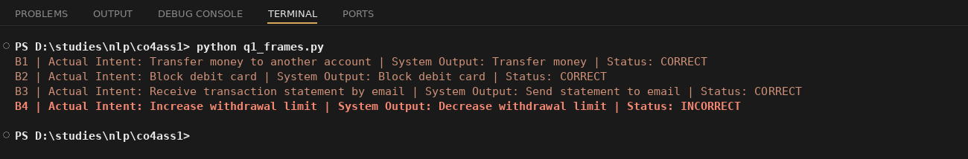

2. First-Order Predicate Calculus for Smart Agriculture
A smart agricultural system monitors crop fields using sensors and logical rules.
Field Data:
Field | Soil Condition | Irrigation Status | Crop
F1 | Dry | Available | Rice
F2 | Wet | Available | Wheat
F3 | Dry | Unavailable | Maize
F4 | Wet | Unavailable | Rice
The system uses the following predicate rules:
- Dry(x) ∧ IrrigationAvailable(x) → NeedsWater(x)
- NeedsWater(x) → Irrigate(x)
- Wet(x) → ¬NeedsWater(x)
- IrrigationUnavailable(x) → ¬Irrigate(x)
- Rice(x) ∧ NeedsWater(x) → PriorityIrrigation(x)
Tasks:
- Represent the field observations using First-Order Predicate Calculus.
- Using the given rules, determine which fields require irrigation.
- Determine whether F1 and F3 should be treated differently by the automated irrigation controller.
- Analyze whether predicate logic alone is sufficient for agricultural decision support when sensor information is incomplete or uncertain.
Answer:
The fields can be written in predicate form like Field(F1), Dry(F1), IrrigationAvailable(F1), Rice(F1) and so on for each field based on the table given.
Applying the rules: F1 is Dry and IrrigationAvailable so NeedsWater(F1) is true, which means Irrigate(F1) is true. F2 is Wet so NeedsWater(F2) is false. F3 is Dry but IrrigationUnavailable, so even though it's dry, the NeedsWater rule doesn't fire (it needs both conditions), and IrrigationUnavailable also directly blocks Irrigate(F3). F4 is Wet so it also does not need water.
F1 and F3 should definitely be treated differently. F1 can actually be irrigated right now, but F3 is dry and stressed and has no irrigation available, so it needs a different action like manual watering, alerting the farmer, or scheduling irrigation once resources are free, instead of just marking it as "no action needed".
Predicate logic alone is not really enough here because it only works with clean true/false facts. In real fields, sensor readings can be uncertain or missing (like a soil sensor giving a borderline reading). For this we'd need probabilistic reasoning or fuzzy logic on top of the predicate rules to handle uncertainty properly.
Below is the code I used to apply these rules on the field data and print the result for each field.
Code:
fields = {
"F1": {"soil": "Dry", "irrigation": "Available", "crop": "Rice"},
"F2": {"soil": "Wet", "irrigation": "Available", "crop": "Wheat"},
"F3": {"soil": "Dry", "irrigation": "Unavailable", "crop": "Maize"},
"F4": {"soil": "Wet", "irrigation": "Unavailable", "crop": "Rice"},
}

def needs_water(field):
return field["soil"] == "Dry" and field["irrigation"] == "Available"

def can_irrigate(field):
if field["irrigation"] == "Unavailable":
return False
return needs_water(field)

def priority_irrigation(field):
return field["crop"] == "Rice" and needs_water(field)

for name, data in fields.items():
water_needed = needs_water(data)
irrigate = can_irrigate(data)
priority = priority_irrigation(data)
print(name, "| Soil:", data["soil"], "| Irrigation:", data["irrigation"], "| Crop:", data["crop"], "| NeedsWater:", water_needed, "| Irrigate:", irrigate, "| PriorityIrrigation:", priority)
Output:
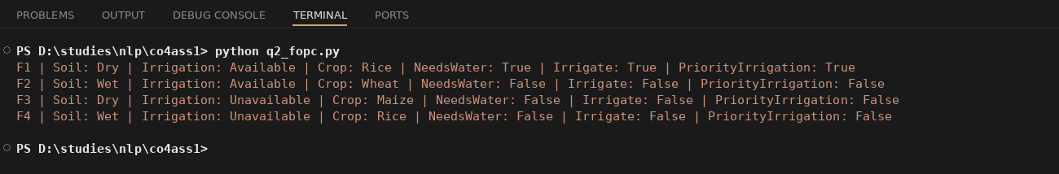

3. Word Sense Disambiguation in a Travel Recommendation System
A travel platform receives search queries containing ambiguous words. The recommendation engine uses surrounding words and user interactions to determine the intended meaning.
Search Query | Possible Sense 1 | Possible Sense 2
"Amazon tour" | Amazon rainforest | Amazon company
"Safari booking" | Wildlife tour | Web browser
"Java vacation" | Java island | Java programming language
"Cruise package" | Ship journey | Cruise software/project
The system records the following user interactions:
Query | User Interaction
Amazon tour | Viewed rainforest trekking packages
Safari booking | Selected wildlife resort packages
Java vacation | Viewed hotels in Bali and Java
Cruise package | Viewed Mediterranean ship packages
However, another user searches: "Safari download for Windows" and clicks a browser download page.
Tasks:
- Determine the intended sense of the ambiguous terms using the available context.
- Identify the lexical and contextual cues that distinguish the possible senses.
- Analyze why the same word may require different interpretations for different users.
- Design an industrial-scale WSD strategy using query context, user history, embeddings, and click behaviour to improve travel recommendations.
Answer:
For each ambiguous query, the system looks at the words around it (context) to pick the right sense. "Amazon tour" with context about rainforest trekking clearly points to Amazon rainforest sense, not the company. "Safari booking" with wildlife resort context means the wildlife tour sense. "Java vacation" with hotels in Bali/Java context means the island sense, not the programming language. "Cruise package" with Mediterranean ship context means the ship journey sense.
The lexical cues are words like rainforest, trekking, wildlife, resort, hotel, island, ship which directly relate to the travel sense, while words like download, install, compiler, software, repository point towards the technology sense instead.
The same word can mean different things for different users because their surrounding context and click behaviour is different. One user's "Safari" click history is about wildlife holidays, but another user searching "Safari download for Windows" is clearly talking about the Safari browser, so the system must use per-user context and not just the word alone.
For an industrial-scale WSD system I would combine the query context words, the user's past click/search history, word embeddings (so similar words like jungle/rainforest are treated close to each other), and real time click behaviour after search to keep updating which sense is more likely, instead of relying on one static rule.
I wrote code below that checks context keywords for each query and also correctly handles the new tricky case ("Safari download for Windows").
Code:
sense_keywords = {
"Amazon tour": {
"Amazon rainforest": ["rainforest", "trekking", "jungle", "wildlife"],
"Amazon company": ["shopping", "delivery", "prime", "order"],
},
"Safari booking": {
"Wildlife tour": ["resort", "wildlife", "jungle", "safari park"],
"Web browser": ["download", "windows", "install", "browser"],
},
"Java vacation": {
"Java island": ["bali", "hotel", "island", "beach"],
"Java programming language": ["code", "compiler", "programming", "jdk"],
},
"Cruise package": {
"Ship journey": ["ship", "mediterranean", "sea", "voyage"],
"Cruise software/project": ["software", "repository", "code", "project"],
},
}

user_context = {
"Amazon tour": "Viewed rainforest trekking packages",
"Safari booking": "Selected wildlife resort packages",
"Java vacation": "Viewed hotels in Bali and Java",
"Cruise package": "Viewed Mediterranean ship packages",
}

def disambiguate(query, context):
context = context.lower()
scores = {}
for sense, keywords in sense_keywords[query].items():
scores[sense] = sum(1 for kw in keywords if kw in context)
return max(scores, key=scores.get)

for query, context in user_context.items():
predicted = disambiguate(query, context)
print(query, "| Context:", context, "| Predicted Sense:", predicted)

new_query = "Safari booking"
new_context = "Safari download for Windows"
predicted = disambiguate(new_query, new_context)
print(new_query, "| Context:", new_context, "| Predicted Sense:", predicted)
Output:
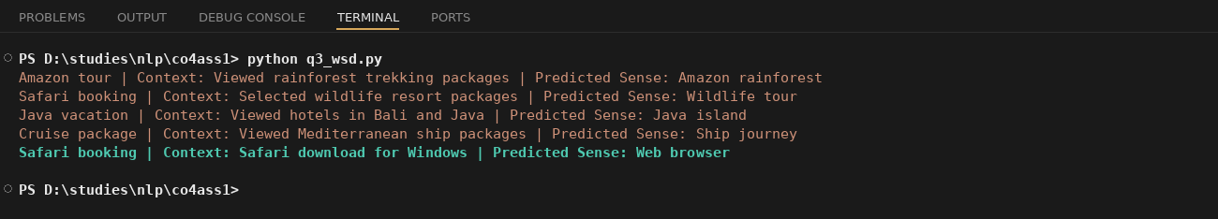

4. Syntax-Driven Semantic Analysis in Legal Document Processing
A legal NLP system analyzes sentences from contracts and assigns semantic roles based on their syntactic structures.
The system produces the following analyses:
Legal Sentence | Parse Structure | Generated Semantic Interpretation
"The supplier delivered the equipment to the buyer." | Subject–Verb–Object | Supplier = Agent, Equipment = Object, Buyer = Recipient
"The buyer received the equipment from the supplier." | Subject–Verb–Object | Buyer = Agent, Equipment = Object, Supplier = Recipient
"The company terminated the contract after the violation." | Subject–Verb–Object | Company = Agent, Contract = Object
"The contract was terminated by the company." | Passive Construction | Contract = Agent, Company = Object
Tasks:
- Analyze how syntactic structure, including active and passive constructions, influences semantic-role assignment.
- Identify the incorrect semantic-role assignments in the given interpretations.
- Explain how confusing grammatical subject with semantic agent can affect automated legal information extraction.
- Recommend a syntax-driven semantic analysis architecture that can correctly handle active voice, passive voice, prepositional phrases, and long-distance dependencies in legal documents.
Answer:
In active voice sentences like "The supplier delivered the equipment to the buyer", the subject naturally becomes the Agent (supplier) and the object becomes the Object (equipment), with the prepositional phrase giving the Recipient (buyer). But in passive voice like "The contract was terminated by the company", the grammatical subject is "contract", but the real Agent is still "company" because passive voice flips the surface order without changing who actually did the action.
The last row is wrong. The system said Contract = Agent and Company = Object, but that's backwards. In this passive sentence the company is the one performing the action (terminating), so Company should be Agent and Contract should be Object.
If the system just blindly takes the grammatical subject as the agent, it will get every passive sentence wrong. In a legal document this is risky because it can flip responsibility, like making it look like the contract terminated itself instead of the company doing it, which changes the legal meaning completely.
A good syntax-driven architecture should first detect the voice (active/passive) using the verb form (was/were + past participle + by), then assign roles based on that: for passive, swap subject/object roles and pull the agent from the "by" phrase. It should also handle prepositional phrases (to/from/by) for recipient and source, and use dependency parsing so it can still get the right roles even with long or complex sentences.
I wrote code below that checks the voice of each sentence and works out the correct agent/object, and it correctly flags the last sentence as incorrect.
Code:
sentences = [
{
"text": "The supplier delivered the equipment to the buyer.",
"voice": "active",
"subject": "supplier",
"object": "equipment",
"prep_object": "buyer",
"given_agent": "Supplier",
"given_object": "Equipment",
"given_recipient": "Buyer",
},
{
"text": "The buyer received the equipment from the supplier.",
"voice": "active",
"subject": "buyer",
"object": "equipment",
"prep_object": "supplier",
"given_agent": "Buyer",
"given_object": "Equipment",
"given_recipient": "Supplier",
},
{
"text": "The company terminated the contract after the violation.",
"voice": "active",
"subject": "company",
"object": "contract",
"prep_object": None,
"given_agent": "Company",
"given_object": "Contract",
"given_recipient": None,
},
{
"text": "The contract was terminated by the company.",
"voice": "passive",
"subject": "contract",
"object": "company",
"prep_object": None,
"given_agent": "Contract",
"given_object": "Company",
"given_recipient": None,
},
]

def correct_roles(entry):
if entry["voice"] == "active":
agent = entry["subject"]
obj = entry["object"]
else:
agent = entry["object"]
obj = entry["subject"]
return agent, obj

for entry in sentences:
correct_agent, correct_object = correct_roles(entry)
given_agent = entry["given_agent"].lower()
given_object = entry["given_object"].lower()
status = "CORRECT" if given_agent == correct_agent and given_object == correct_object else "INCORRECT"
print(entry["text"])
print(" Voice:", entry["voice"], "| System Agent:", entry["given_agent"], "| System Object:", entry["given_object"])
print(" Correct Agent:", correct_agent, "| Correct Object:", correct_object, "| Status:", status)
Output:
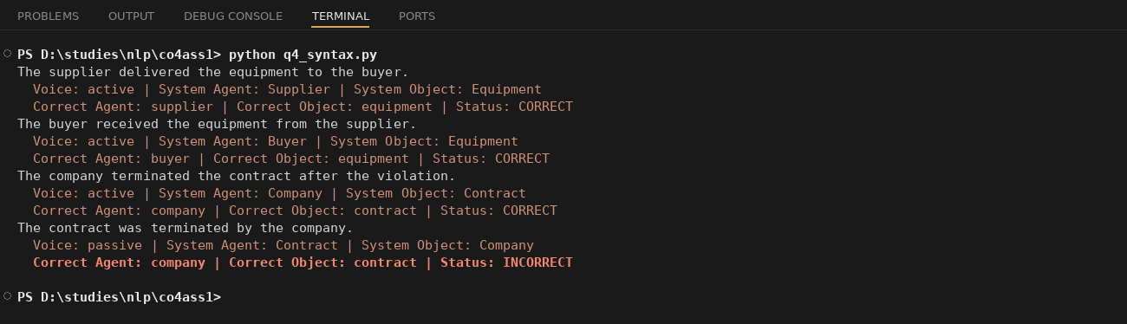

Rubrics for Calculation

Criteria | Weightage | Level 4 (Exemplary) | Level 3 (Proficient) | Level 2 (Developing) | Level 1 (Beginning)
Understanding of Data | 25% | Accurately interprets all data patterns, trends, and relationships | Interprets data correctly with minor gaps | Partial understanding; misses key trends | Misinterprets or fails to understand data
Analysis | 25% | Provides deep analysis with strong logical reasoning and justification | Provides reasonable analysis with some justification | Basic analysis with weak reasoning | No meaningful analysis provided
Application of Concepts | 20% | Effectively applies relevant concepts/tools to interpret data accurately | Applies concepts with minor errors | Limited application; requires guidance | Unable to apply concepts to data
Conclusion | 20% | Draws clear, meaningful conclusions with strong insights and implications | Provides valid conclusions with moderate insights | Conclusions are vague or weak | No clear or valid conclusions
Clarity | 10% | Presents interpretation clearly using proper structure, visuals, and terminology | Generally clear with minor issues | Lacks clarity or proper structure | Poor presentation and difficult to understand

Q. No. / Criteria Level | Understanding of Data | Analysis | Application of Concepts | Conclusion | Clarity | Sub. Total | Total %
1 | 5 | 5 | 4 | 4 | 4 | 23
2 | 5 | 4 | 4 | 4 | 4 | 22
3 | 5 | 5 | 5 | 4 | 5 | 24
4 | 5 | 4 | 4 | 4 | 5 | 23

Faculty In-charge | Course Coordinator | Program Director
Signature: _______________ | Signature: _______________ | Signature: _______________
Date: ___________________ | Date: ___________________ | Date: ___________________

